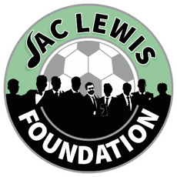

  - City Cluster Counselling Service
  - FREE Coping Skills Workshop
- Our coping skills workshop is designed to provide you with practical tools and a supportive community to navigate life's challenges.
- Whether you're dealing with stress, anxiety, or simply looking to bolster your resilience, this workshop will offer a compassionate space for growth and healing.
- Throughout the workshop, participants will engage in a variety of activities and discussions aimed at identifying personal stressors and exploring effective coping mechanisms.
- From mindfulness exercises and breathing techniques to journaling and positive affirmations, each session is crafted to help you discover what works best for you.
- Our experienced facilitators will guide you with empathy and understanding, ensuring that you feel heard and supported every step of the way.
- By the end of the workshop, you'll not only have a toolkit of practical coping strategies but also the confidence to implement them in your daily life.

  - 12th September 2024 10-12pm
Online - Via Zoom
To book onto the workshop please:
Email Admin@jaclewisfoundation.co.uk
Call or Text 03301336510

